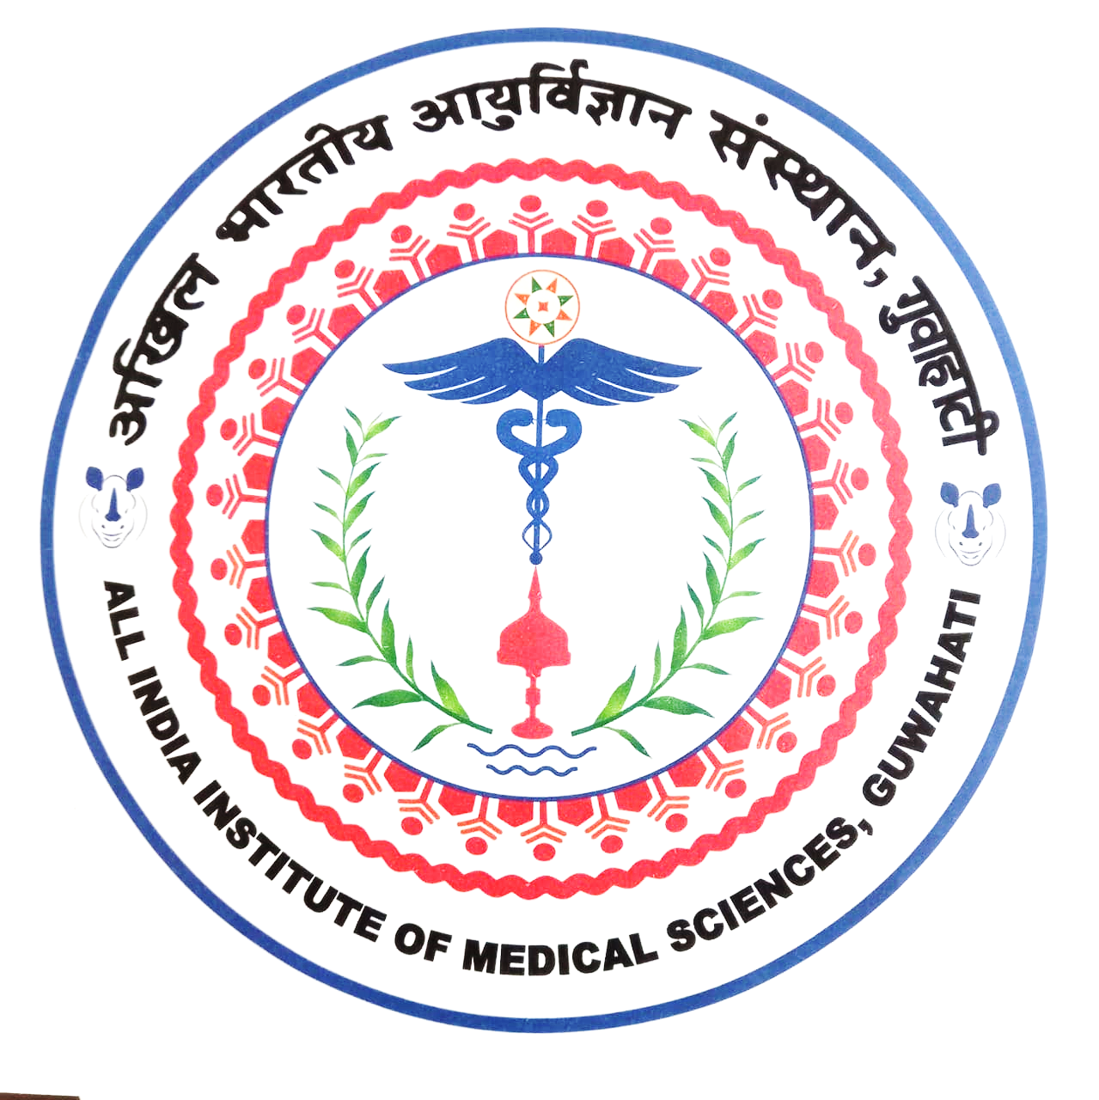 | अखिल भारतीय आयुर्विज्ञान संस्थान (एम्स), गुवाहाटी  All India Institute of Medical Sciences, Guwahati  स्वास्थ्य और परिवार कल्याण मंत्रालय,भारत सरकार के तत्वावधान में एक वैधानिक निकाय  (A statutory body under the aegis of Ministry of Health and Family Welfare, GoI)
_________________________________________________________________________________________________
(Statement to be furnished on half-yearly basis by the Faculties/ Officers to the Administration)

Name of the Applicant:
Designation:
Department:
Pay Level & Basic Pay (in Rs.):

I certify that I have spent Rs. ______ towards the purchase of Newspaper(s) for the month of: -

- Jan- June 20_____________
Or
- July- December 20________

[Only one option is to be ticked]

I further declare that (i) the Newspaper(s) in respect of which reimbursement is claimed is/ are purchased by me. (ii) The amount for which the reimbursement is being claimed has actually been paid by me and has not/ will not be claimed by any other source.

Date: ________________ Signature:

Name:

